# DAILY ASSESSMENT

|  |  |  |  |
| --- | --- | --- | --- |
| Date: | 30/06/2020 | Name: | Chesmi B R |
| Course: | **IIRS** | USN: | 4AL16EC100 |
| Topic: | **Concepts of stereophotogrammetry** | Semester & Section: | 8TH SEM & A Section |
| Github Repository: | chesmibr |  |  |

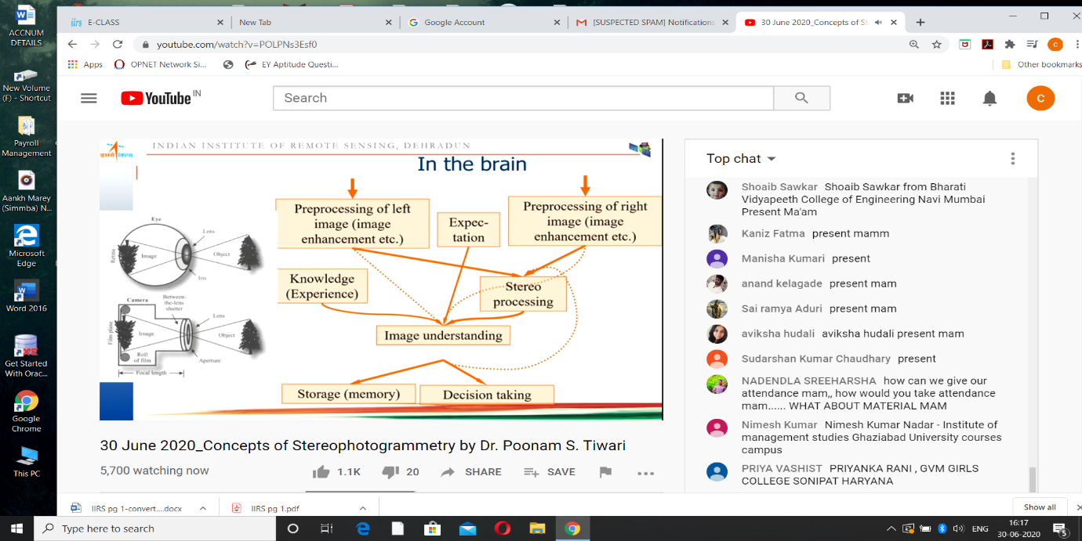

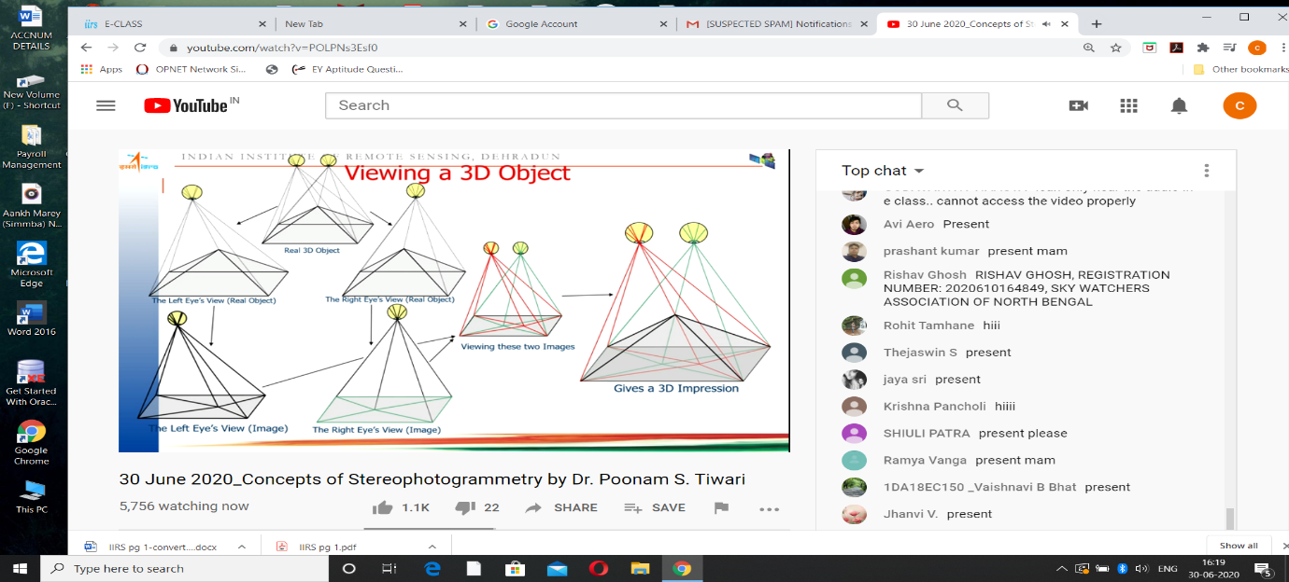

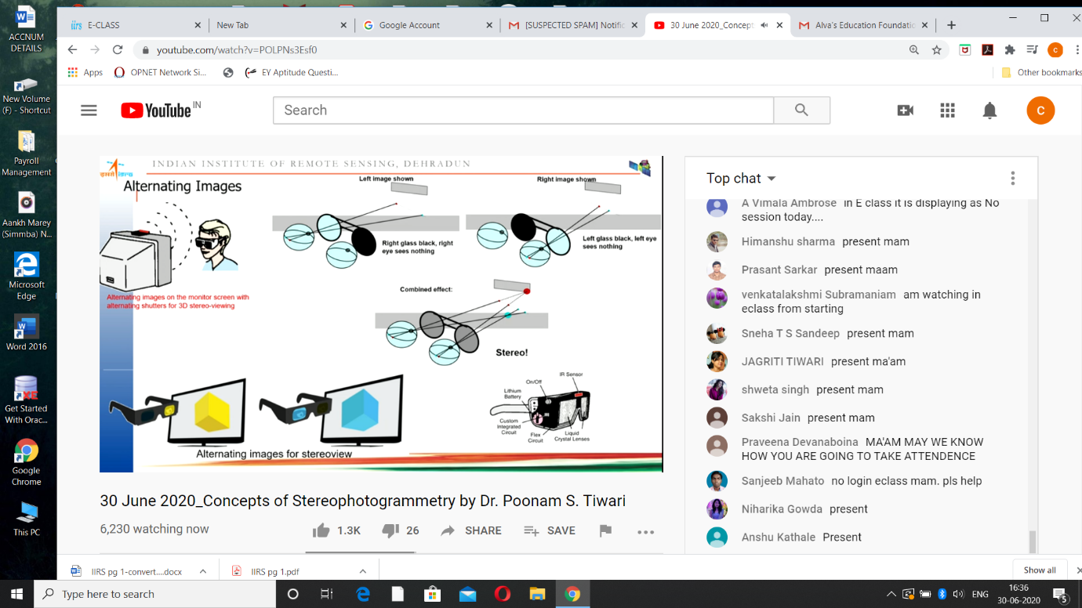

3D photography or stereoscopic photography is the art of capturing and displaying two slightly offset photographs to create three dimensional images.  
The 3D effect works because of a principle called [stereopsis](http://en.wikipedia.org/wiki/Stereopsis). Each eye is in a different location, and as a result, it sees a slightly different image. The difference between these images is what lets us perceive depth.

This effect can be replicated with photography by taking two pictures of the subject that are offset by the same distance as your pupils (about 2.5 inches or 63 mm). The two images are then viewed so that each eye sees only the corresponding picture. Your brain puts the two images together just as it does for normal vision and you perceive a single three dimensional image.

## Step 1: How to Take Stereoscopic 3D Picture.

Taking stereoscopic pictures is simple. All you need is a camera and a tripod. Set up your camera and tripod on a level surface. Compose your shot with the main subject in the center and take a picture. Then slide the tripod 2.5 inches (about 63 mm) to either the right or the left. If necessary adjust the direction of your camera so that the subject is again in center of the shot. This should only be necessary for close up shots. Then take a second picture from the new position.  
  
This method works great for subjects that are still. But if you want to capture 3D images of moving objects, then you will need some additional hardware. If you have two cameras, then you can construct a simple two camera rig that mounts onto your tripod. In this kind of setup, the cameras are mounted 2.5 inches apart from center to center. To see a good example, check out [this rig](https://www.instructables.com/id/How-to-make-3D-stereoscopic-films/) by user [ciscu92](https://www.instructables.com/member/ciscu92/). Then when taking the picture, you need to activate both cameras at the same time.  
  
If you don't have two cameras, you can construct a mirror splitter like [this one](https://www.instructables.com/id/Make-a-3-D-Stereoscope-Slide-and-Video-Shooter/) by user [courtervideo](https://www.instructables.com/member/courtervideo/). This rig uses mirrors to split the image and space each part at the appropriate distance. This lets you capture both views with a single camera.

Step 2: Methods for Display and View 3D Images: There are many different ways to display and view a stereoscopic 3D image. Here are some of the most commonforms.3D viewing systems with glasses: These systems superimpose the right and left views on the screen. The observer wears glasses that filter the image so that each eye sees only the appropriate view.  
  
Color filtering glasses: The picture is displayed in two colors (one for each view). These glasses use a colored gels to selectively filter out the opposite color image. The most common colors used are Red/Cyan, Green/Magenta, and Blue/Yellow  
  
Polarized glasses: Polarized systems use two sets of polarized light filters. The picture is projected through one pair of polarized filters. The right and left view have opposite polarity. The viewer wears glasses with another pair of polarized filters. Each filter lets the image with matching polarity pass through but blocks the opposite polarity. This system has an advantage over colored filter systems in that it is able to display full color pictures. The disadvantage of this system is that it either requires two projectors (like you see in movie theaters) or your resolution is limited (such as in interleaved television displays).  
  
Active shutter 3D glasses: These systems switch the display between the right and left views every other frame. The glasses are wirelessly synced to the display and use LCD's in each lens to black out the appropriate eye at the appropriate time. This requires the displays to run at 48 frames per second instead of 24. These systems give a superior picture quality but cost substantially more than **systems.**  
  
Wiggle 3D: The picture is rapidly switched between the left and right views about every 0.10 seconds. This approximates a 3D effect without glasses. However, many people find it disorienting to view these images and the rate of frameswitching makes it impractical for viewing moving images.  
  
Mirror Split: This system uses one or two mirrors to virtually overlap the images. One of the views is often mirrored horizontally.

## Parallel: The two views are displayed side by side. The easiest way to view these pictures is with a tool called a stereoscope.

## Cross-eyed: The two views are place side by side like with the parallel viewing system. However, in this system the right view is placed on the left side and the left view is placed on the right side. They are viewed by the observer crossing their eyes to look at the appropriate image.

## Step 3: How to View Cross-eyed 3D Image

The simplest method of displaying and viewing 3D images is the cross-eyed method. This is the only method that doesn't require any additional viewing tools. To display these images, the two pictures are positioned side by side with the right view on the left side and the left view on the right side. Occasionally, a small dot is added above each picture to mark the center point.  
  
To view these images, place the pictures centered in front of you. Then gradually cross your eyes so that the pictures appear to overlap. Eventually you will see three images. Try to bring the center image into focus. When in focus, this center image will appear to be in 3D. This is techniques is also used to view many Magic Eyepuzzles.  
  
Unfortunately many people find the cross-eyed viewing method uncomfortable to maintain for more than a few seconds. If you experience this problem, you may wish to use the parallel viewing method detailed in the next step.

## Step 4: How to View Parallel 3D Images With a Stereoscope

Parallel 3D images are typically viewed using a tool called a stereoscope. This device uses lenses to help the observer to focus one eye on each picture. There are many different styles of stereoscopes. You are probably most familiar with the View-Master that is produced by Fisher-Price. Older styles such as the Brewster stereoscope and the Holmes stereoscopes can still be found in many antique stores. The viewing cards (called stereographs) can also be found at some antique stores or you can make your own. Just print off a pair of stereoscopic pictures so that each image is about 2.5-3 inches in width .

These viewers are quite simple to operate. You just place the picture card in the picture holder and look through the viewing lenses. Some models let you adjust the position of the picture to be more adaptable to different users.

## Step 5: How to Make Your Own Simple Stereoscope.

To make a simple stereoscope, all you need is a pair of reading glasses and a small machine screw (at least 1/2 inch long). When choosing a pair of reading glasses, there are two traits that you want to look for. It needs to have a high magnifying power (preferably 3.0 to 3.5), and it needs to have temples (the bar on the side of your face) that are wide enough to fit a machine screw through them.  
  
Start by cutting the glasses in half at the middle of the bridge. Then use a file or grinder to round off the cut edges. Next, cut each temple about 1/2" past the hinge. Again round off the cut ends. Drill a hole in the centers of the remaining temple pieces that is just large enough to tightly fit the machine screw. Position the two eye pieces so that the temples are about 1/2 inch apart. Then screw the machine screw through one temple and into the second temple. Now you have a simple pocket sized stereoscope.

To use your new stereoscope, hold it up to your face with the temples and bolt sticking out on the side that is nearest to your face. Position it so that the lenses are about two inches away from your eyes. Then hold the stereograph card about 12 inches away from your face. You will probably need to make adjustments to make it is easier to view based on your eyes and the lenses that you are working with. Play around with the spacing between your eyes, the lenses and the card. You can also adjust the spacing between the two lenses. I have found that the temples can be spaced anywhere from 1/4" apart to 1" apart and it still works. The spacing that you use will depend how what you find more comfortable.